1.

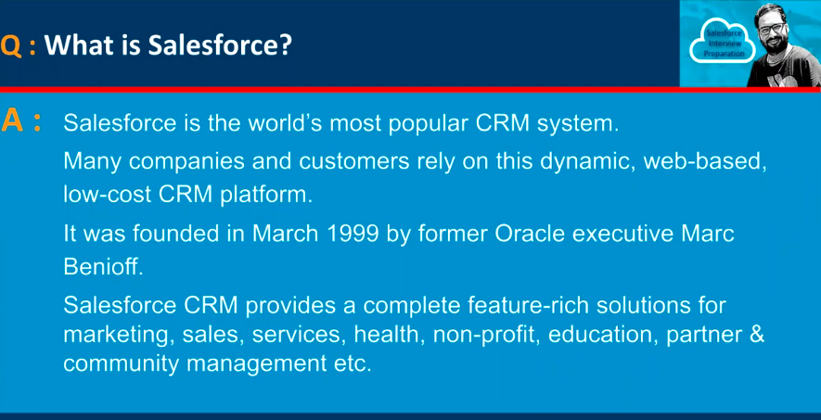

2.

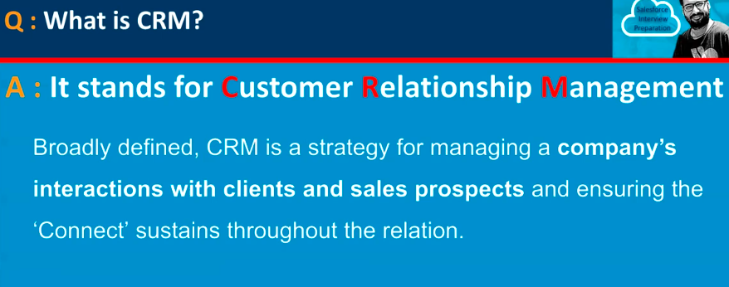

3.

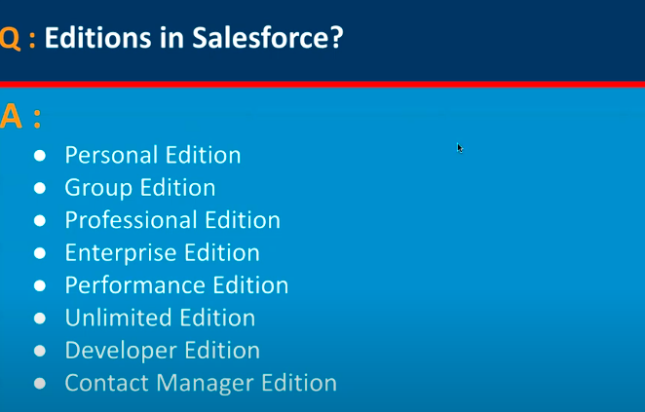

**📌 Salesforce Editions**

1. **Essentials**
   * Very basic CRM (for small businesses).
   * Limited customization, only up to 10 users.
   * Rarely used in big real-time projects.
2. **Professional**
   * More features than Essentials.
   * No advanced automation (like coding/triggers).
   * Usually for small-to-medium businesses.
3. **Enterprise** ✅ (Most Common in Real-Time)
   * Includes **Apex, Triggers, APIs, Workflow, Profiles, Permission Sets, Custom Objects** etc.
   * Used by mid-size to large companies.
   * **This is the most widely used edition in real-time Salesforce projects.**
4. **Unlimited**
   * Everything from Enterprise + more (like unlimited custom apps, more storage, premium support).
   * Used by **large enterprises** that need high scalability.
5. **Developer Edition**
   * Free edition provided for **learning, development, and testing**.
   * Comes with all core features (Apex, API, Lightning, etc.), but with **limits** (small data storage, limited users).
   * Not used in real-time for business, only for **developers**.

**📊 Real-time Usage**

* **Enterprise Edition → 70%+ companies** use this in production.
* **Unlimited Edition → big enterprises** (like banks, telecoms, MNCs).
* **Developer Edition → for learning, sandboxing, and coding practice.**

✅ **So in short:**  
In **real-time projects**, Salesforce **Enterprise Edition** is the most commonly used.  
For **learning & practice**, you use **Developer Edition** (the free one Salesforce gives you).

4.

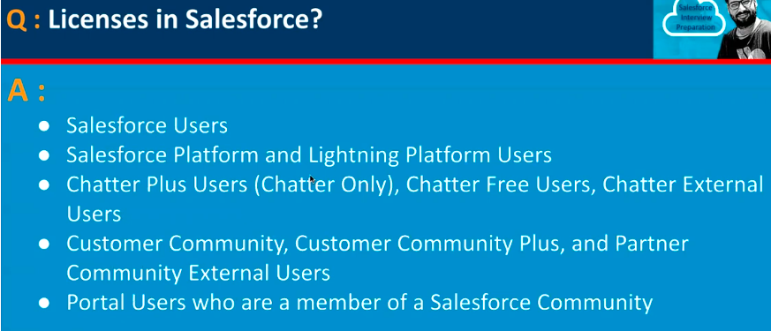

5.

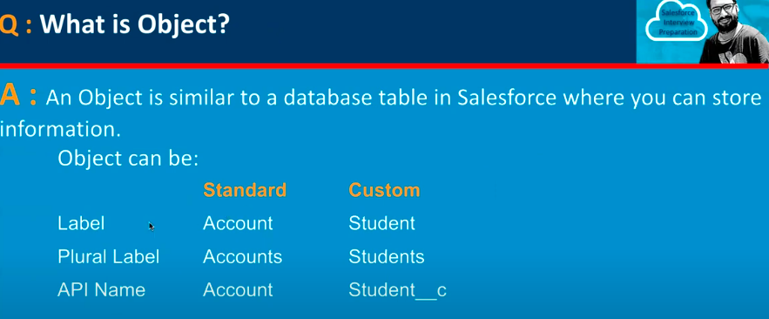

6.

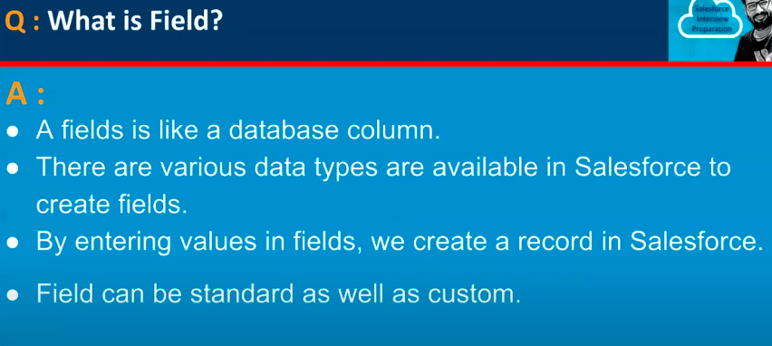

7.

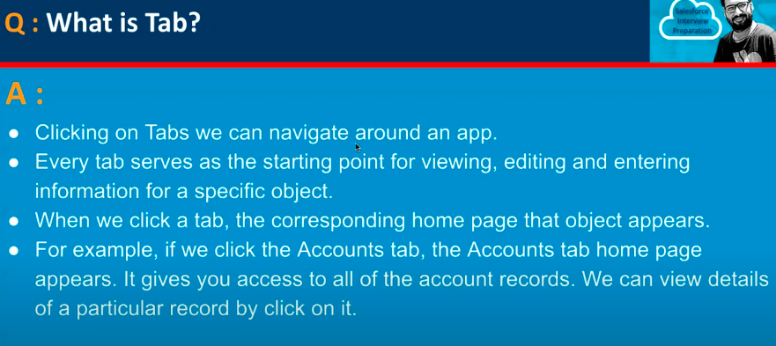

8.

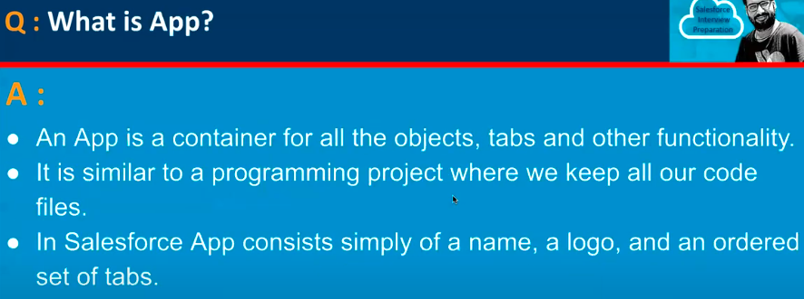

9.

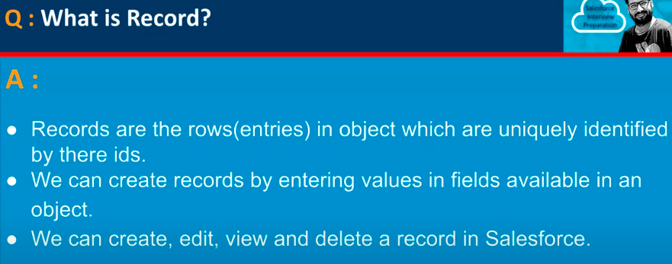

10.

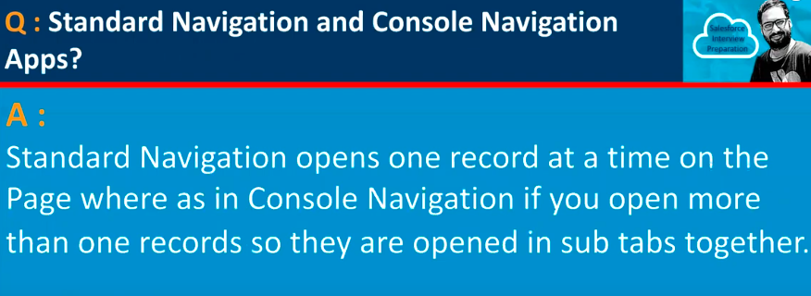

11.

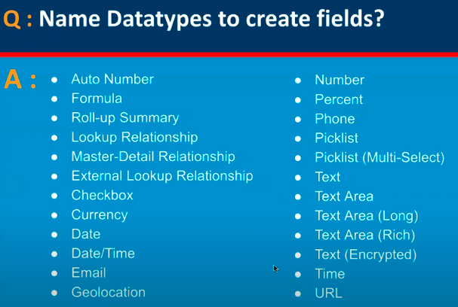

12.

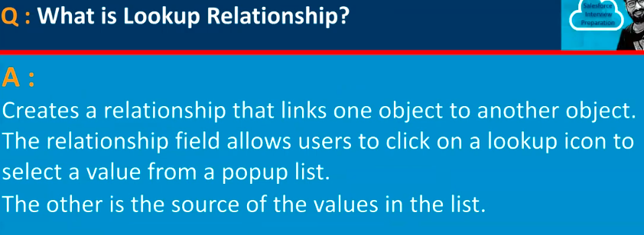

13.

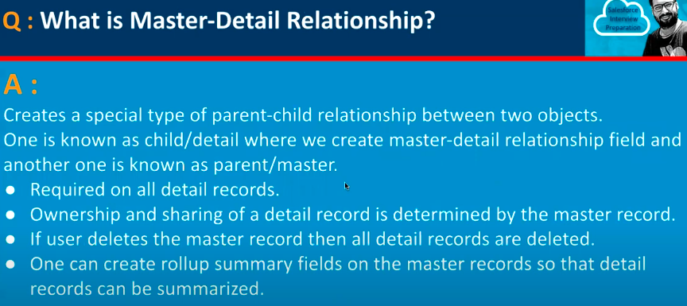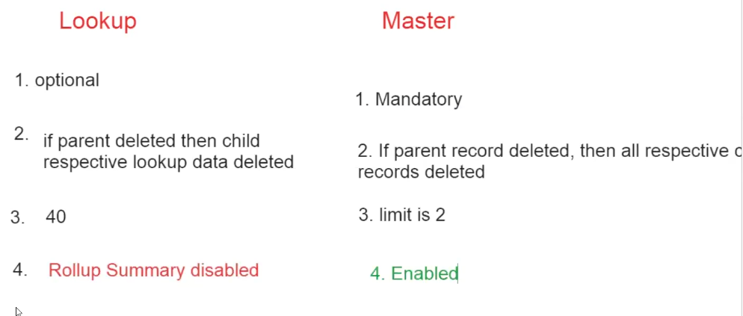

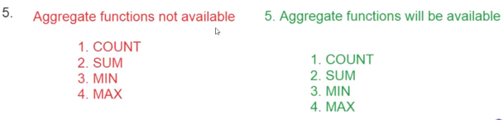

14.

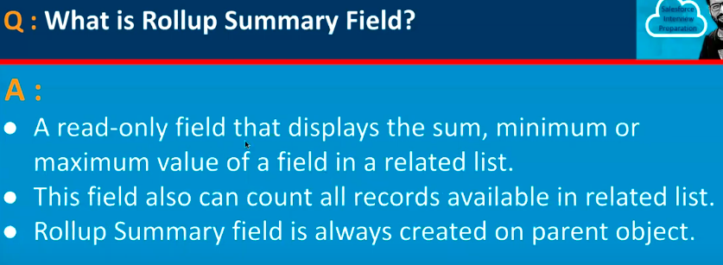

15.

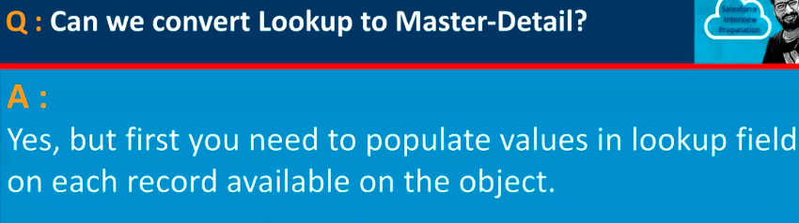

16.

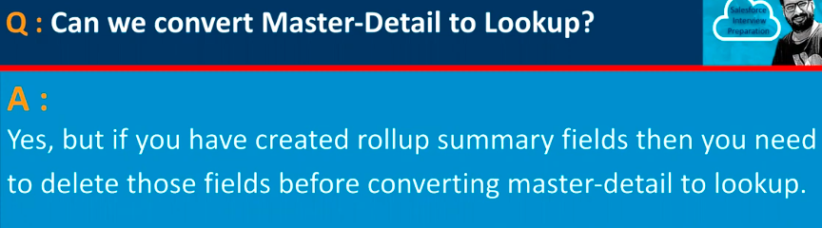

17.

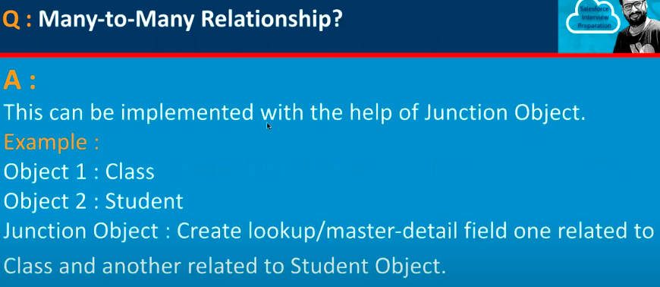

18.

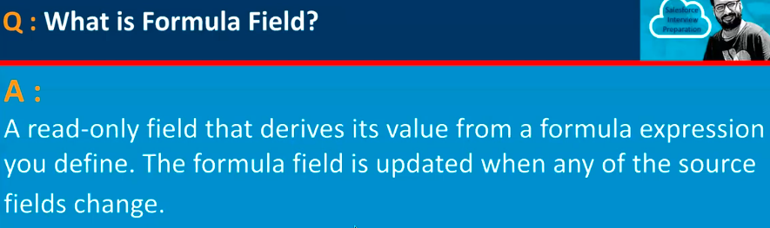

19.

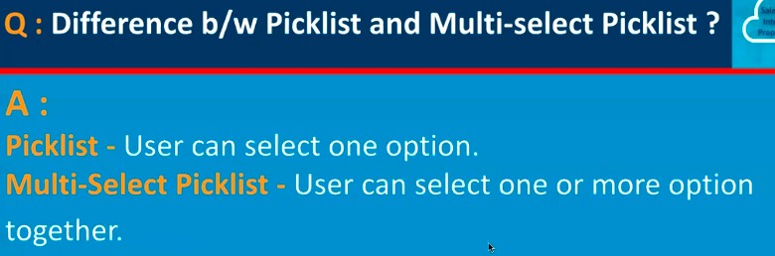

20.

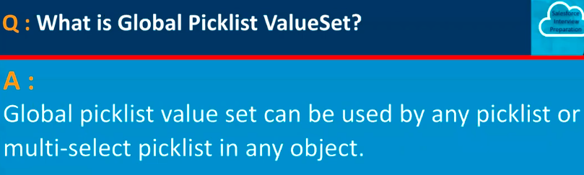

21.

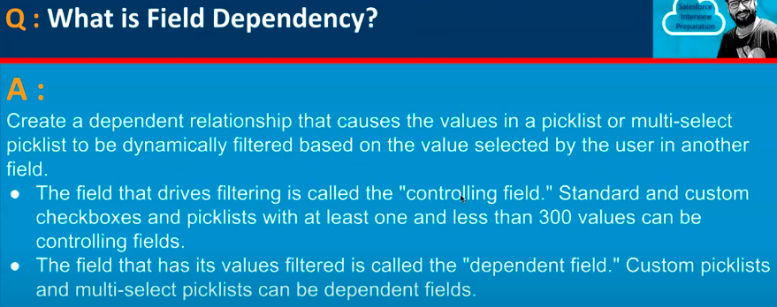

**Dependent Relationship in Salesforce**

**1. Field Dependency (Most Common Meaning)**

* A **dependent picklist** is a picklist whose available values **depend on the value selected in another field** (called the **controlling field**).
* This is used to guide users and prevent invalid data entry.

✅ Example:

* **Controlling Field**: Country
* **Dependent Field**: State
* If Country = India, show AP, Telangana, Karnataka.
* If Country = USA, show California, Texas, New York.

22.

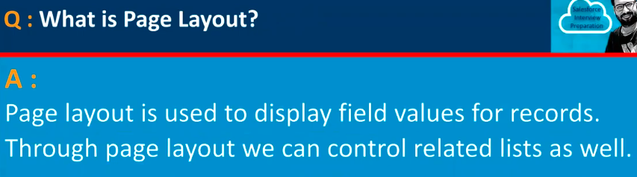

23.

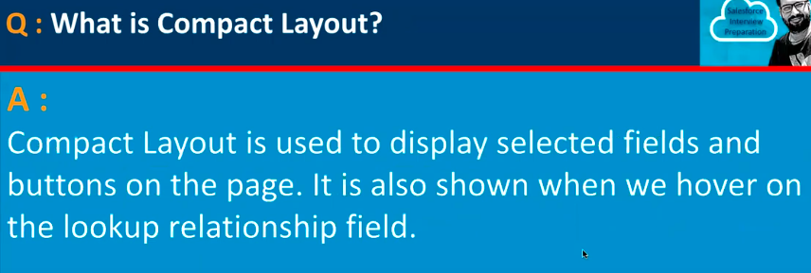

Not all field types are supported. The following **data types** are **NOT supported** in Compact Layouts:

1. **Long Text Area**
2. **Rich Text Area**
3. **Multi-Select Picklist**
4. **Text Area (plain)**

**Page Layout = Full record page (detailed view).**  
👉 **Compact Layout = Small summary (top highlight panel / hover preview).**

**Compact Layouts are only available in Lightning Experience and Salesforce Mobile App.**

**Not available in Classic UI.**

**Compact Layout** controls **which fields appear in the header (highlights panel)** of a record page in Salesforce (Lightning & mobile app).

It gives users a **quick view of the most important information** without scrolling.

24.

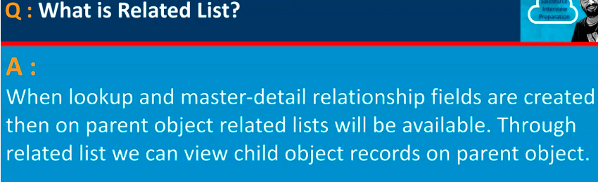

A **Related List** is a section on a record’s detail page that shows **related records from another object**.

It appears **below the record details** and helps users see and manage **child or related data** without navigating away.

A **Related List** displays **all records related to the current record**, based on defined relationships, allowing quick access and management.

25.

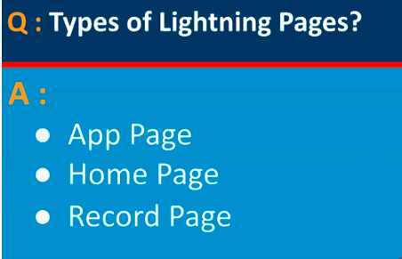

* In **Lightning Experience**, we use **Lightning App Builder** to design record pages, add related lists, tabs, components, etc.
* In **Salesforce Classic**, there’s **no App Builder**. Instead, everything is managed through **Page Layouts** and **Related Lists**.

Here’s how it works in **Classic (like in your screenshot):**

1. **Relationship Field Setup**
   * First, the Patient info object has a lookup or master-detail field to the Doctor Info object.
   * This creates the parent–child relationship.
2. **Page Layout Control**
   * Go to **Setup → Customize → Doctor Info → Page Layouts**.
   * Edit the layout for Doctor Info.
   * In the **Related Lists** section, drag the **Patient infos related list** onto the layout.
   * Save it.
3. **Result**
   * When you open a **Doctor Info** record in Classic, Salesforce shows the **Patient infos related list** automatically (like in your screenshot).
   * Each Patient record that has this Doctor selected in its lookup field will show up there.

👉 So in Classic: **Page Layouts + Related Lists** replace what Lightning App Builder does.

**in Lightning Experience**

* You get **Lightning App Builder**, which is much more powerful.
* You can design **Record Pages** (like Doctor Info page) with drag-and-drop.
* Components you can add:
  + **Related Lists** (like Patient infos)
  + **Tabs**
  + **Report Charts**
  + **Custom Components (LWC/Aura/Visualforce)**
* You can show/hide sections using **Dynamic Forms** and **Visibility Rules**.

26.

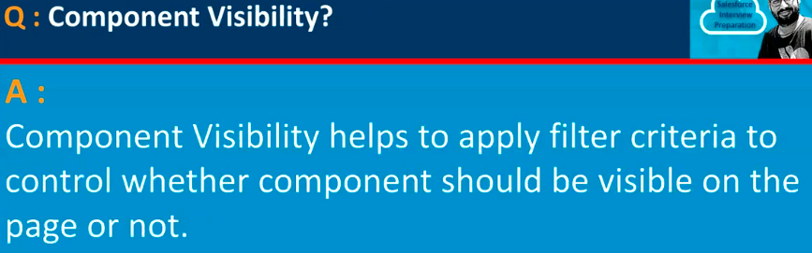

27.

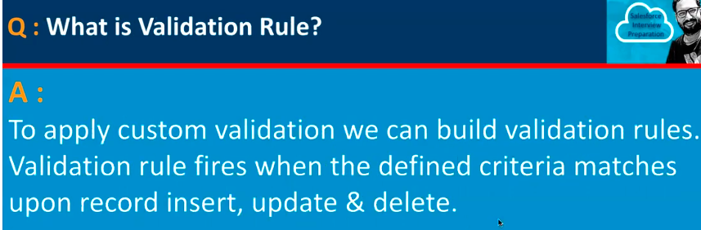

28.

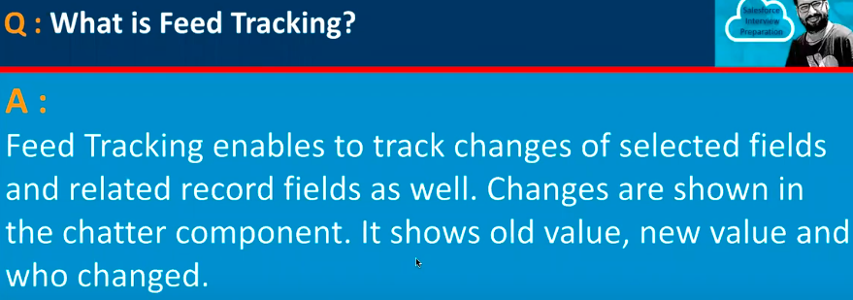

29.

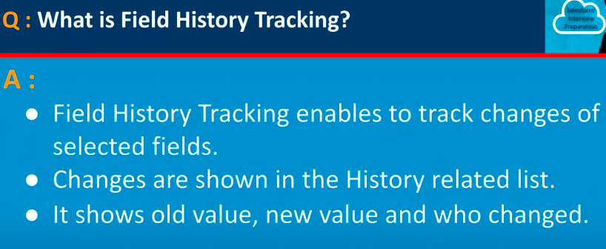

The changes will be seen in the history related field.

**Field History Tracking** = Audit log of field changes (old value → new value).

**Feed Tracking** = Chatter updates about field changes (for collaboration).

30.

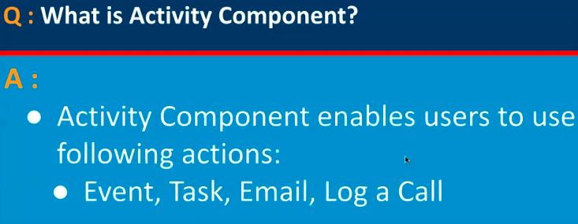

31.

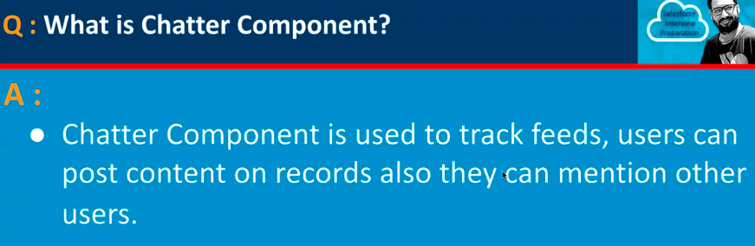

32.

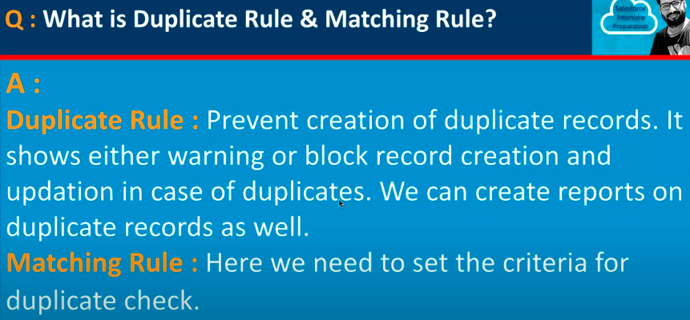

**Matching Rule = Defines duplicate condition**

**Duplicate Rule = Defines duplicate action**

Works in **UI (Classic + Lightning)**

Works in **API/Dataloader** if rule is set to “Enforce Sharing Rules”

33.

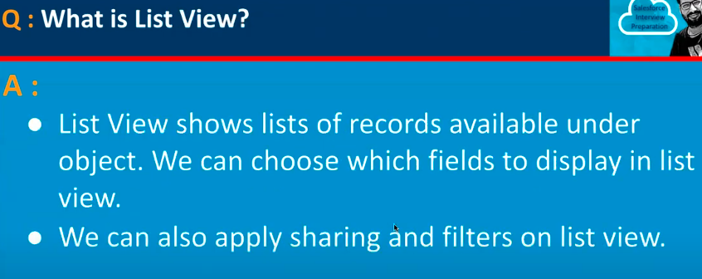

34.

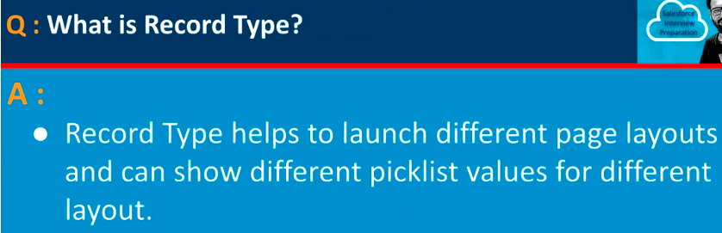

35.

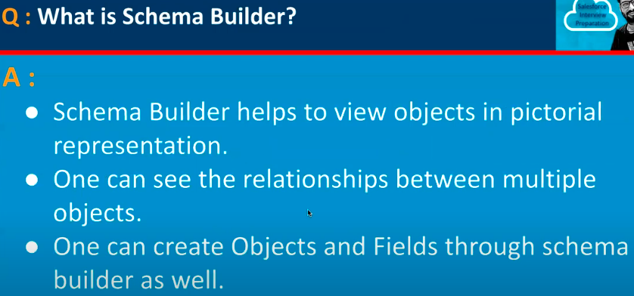

36.

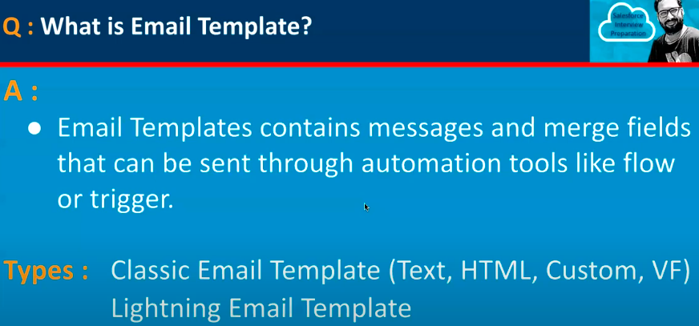

37.

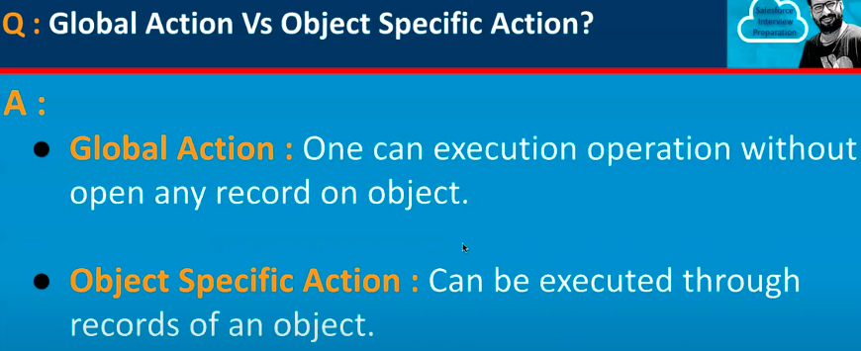

38.

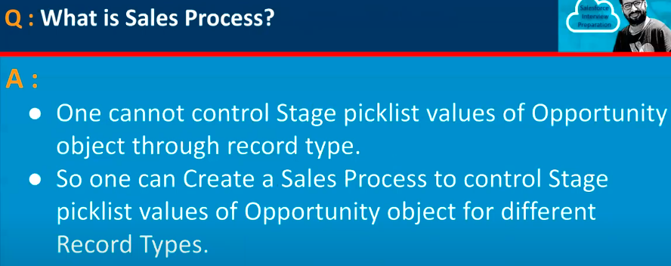

**Stage** is a **picklist field** that represents the **current status** or **progress step** of a record.

Most commonly used in **Opportunities** (Sales process) → e.g. *Prospecting, Qualification, Proposal, Closed Won, Closed Lost*.

But you can also create your own picklist stages for **custom objects** (like Patient Treatment Stage)

Stage Picklist = Progress steps of a record (like pipeline stages in sales, or treatment stages in hospital).

39.

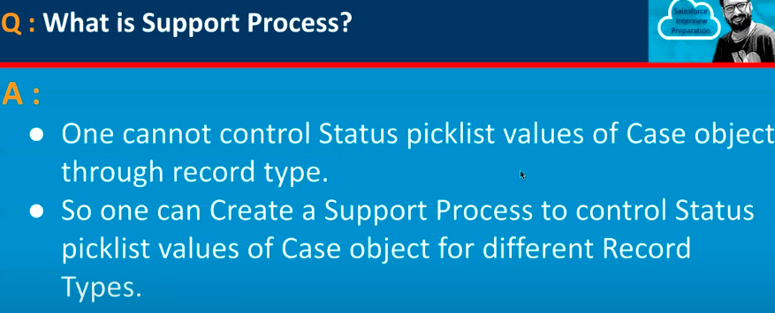

Support Process = Defines which Case Status values are available in a Record Type (used only for Cases).

40.

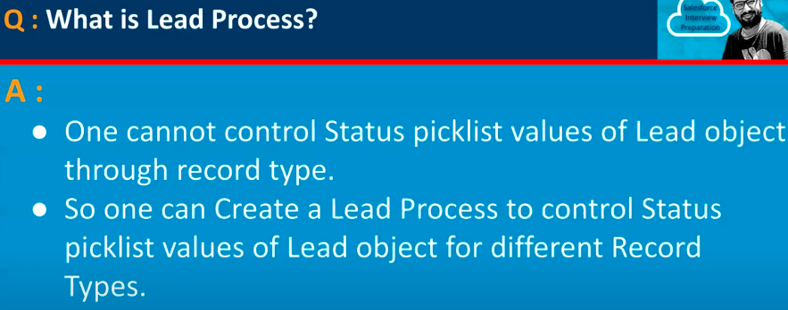

41.

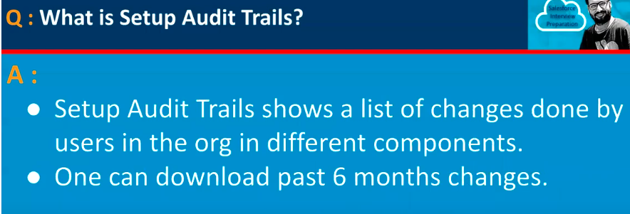

42.

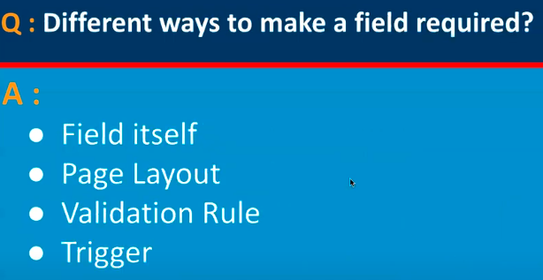

43.

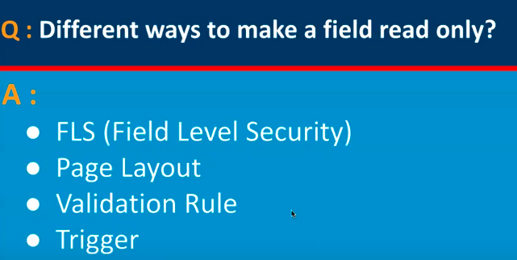

44.

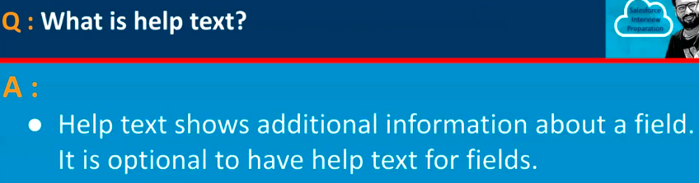

45.

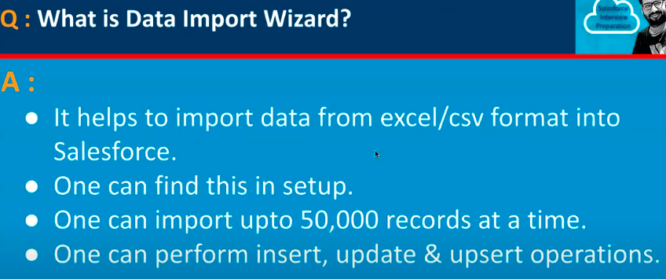

46.

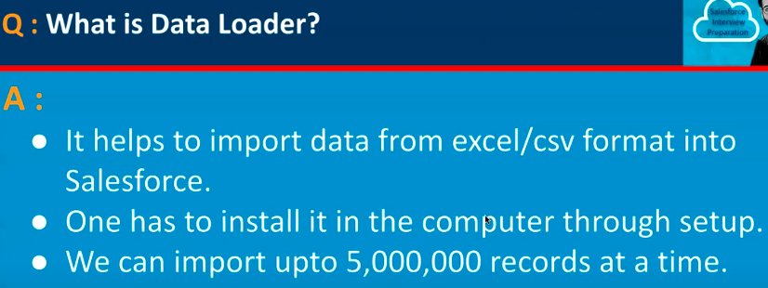

47.

